|  |
| --- |
| EPAM Systems, RD Dep. |
| MTN.BI.08 PL/SQL Techniques |

|  |  |  |  |  |  |
| --- | --- | --- | --- | --- | --- |
| REVISION HISTORY | | | | | |
| Ver. | Description of Change | Author | Date | Approved | |
| Name | Effective Date |
| 1.0 | Initial status | Hanna Hul | 12-JAN-2012 |  |  |

Contents

1. Create Packages for Reload Dimension from DW to SAL 3

2. Test Your Data 3

3. Task Results 3

# Create packages to load dimensions from ST (staging) to SL (star layer)

The Main Task is to create independent packages to reload dimensions according to your DWH solution concept that was developed on Module 6 Introduction to DWH.

Required points:

* Create all required dim objects on SL Layer

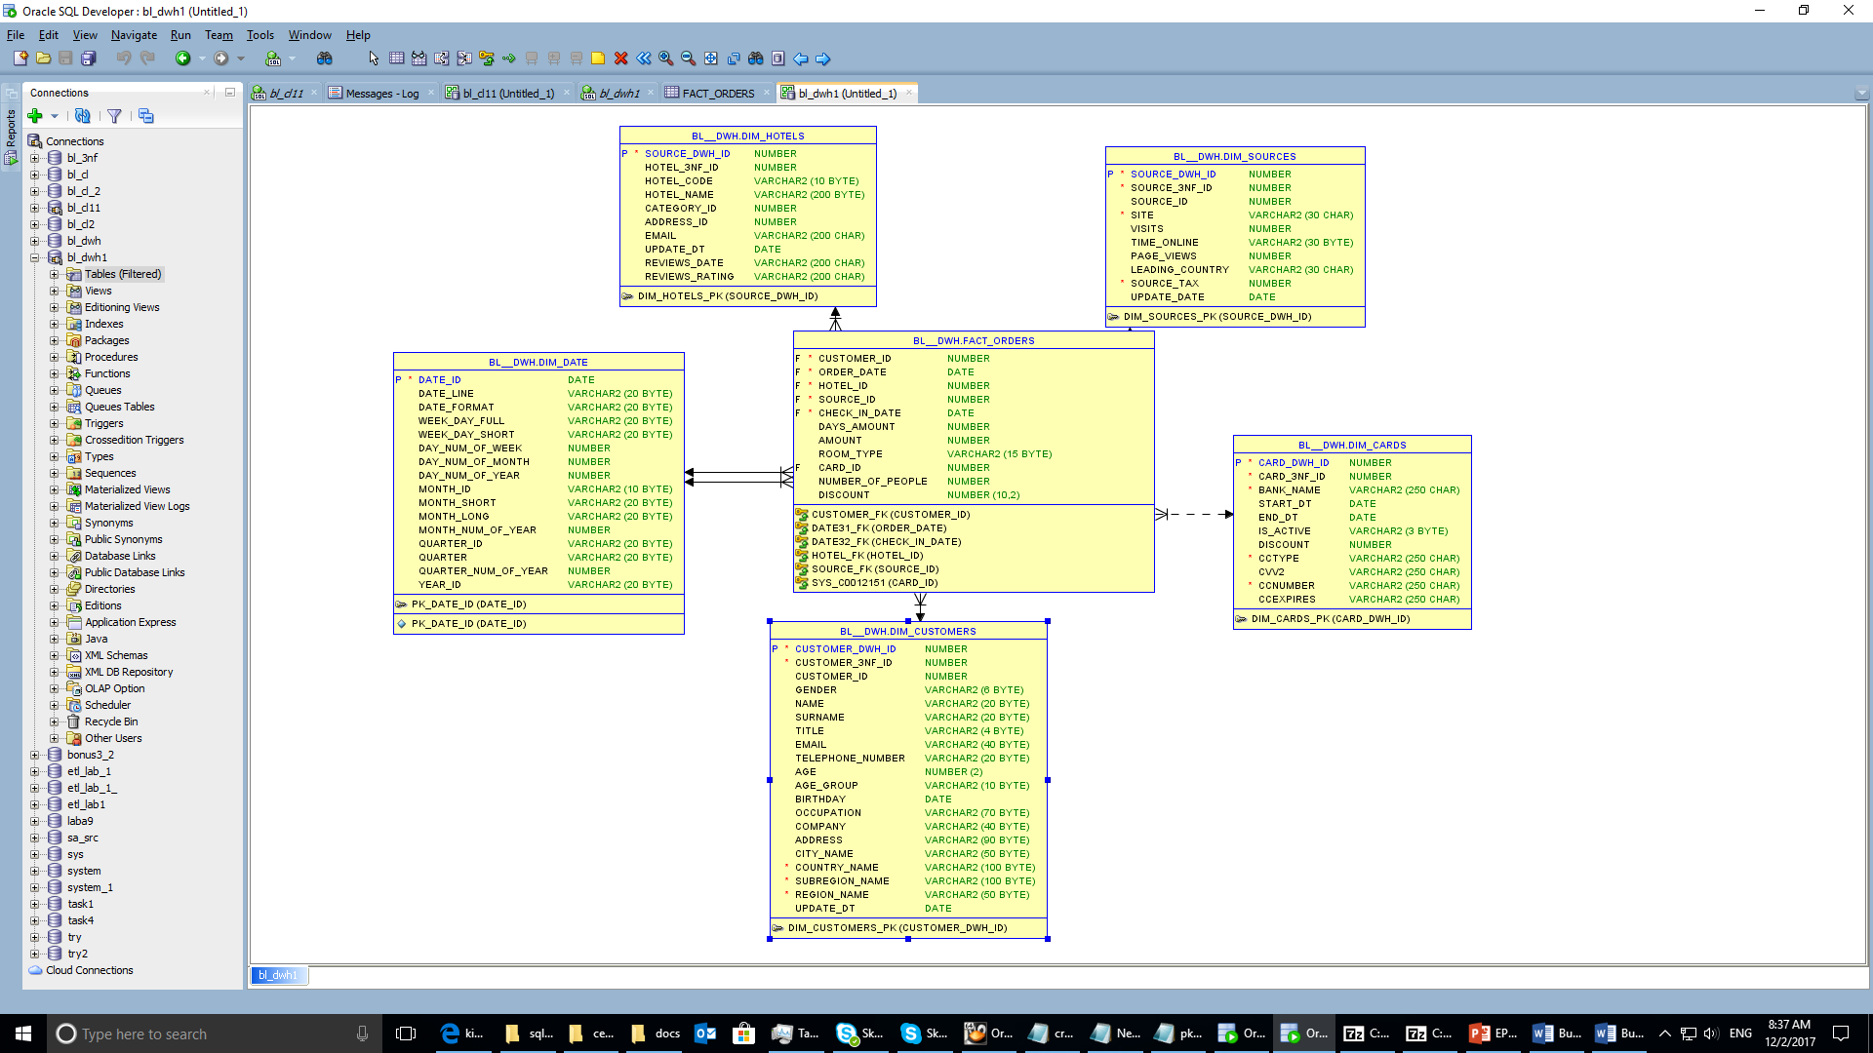

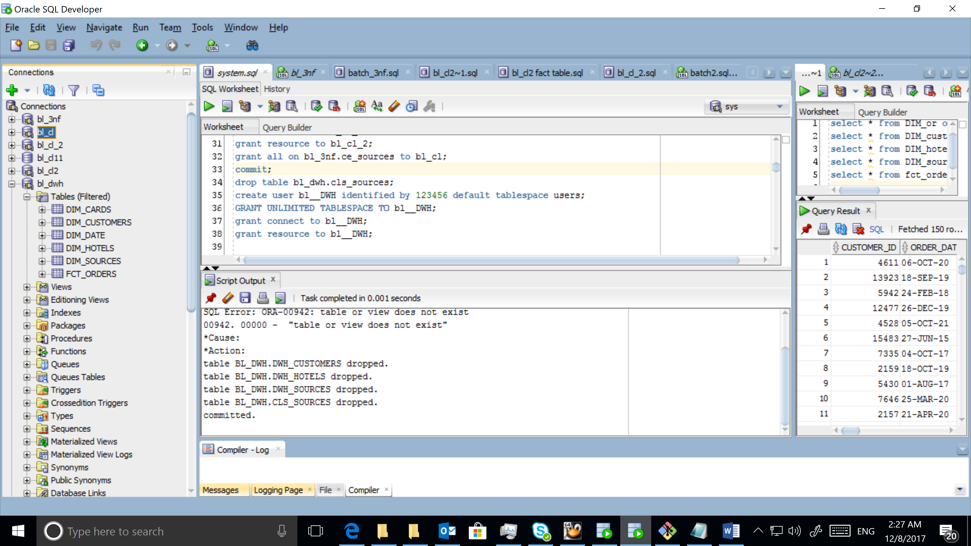

* Create packages to load dim data (one package = one dimension) on SL_CL

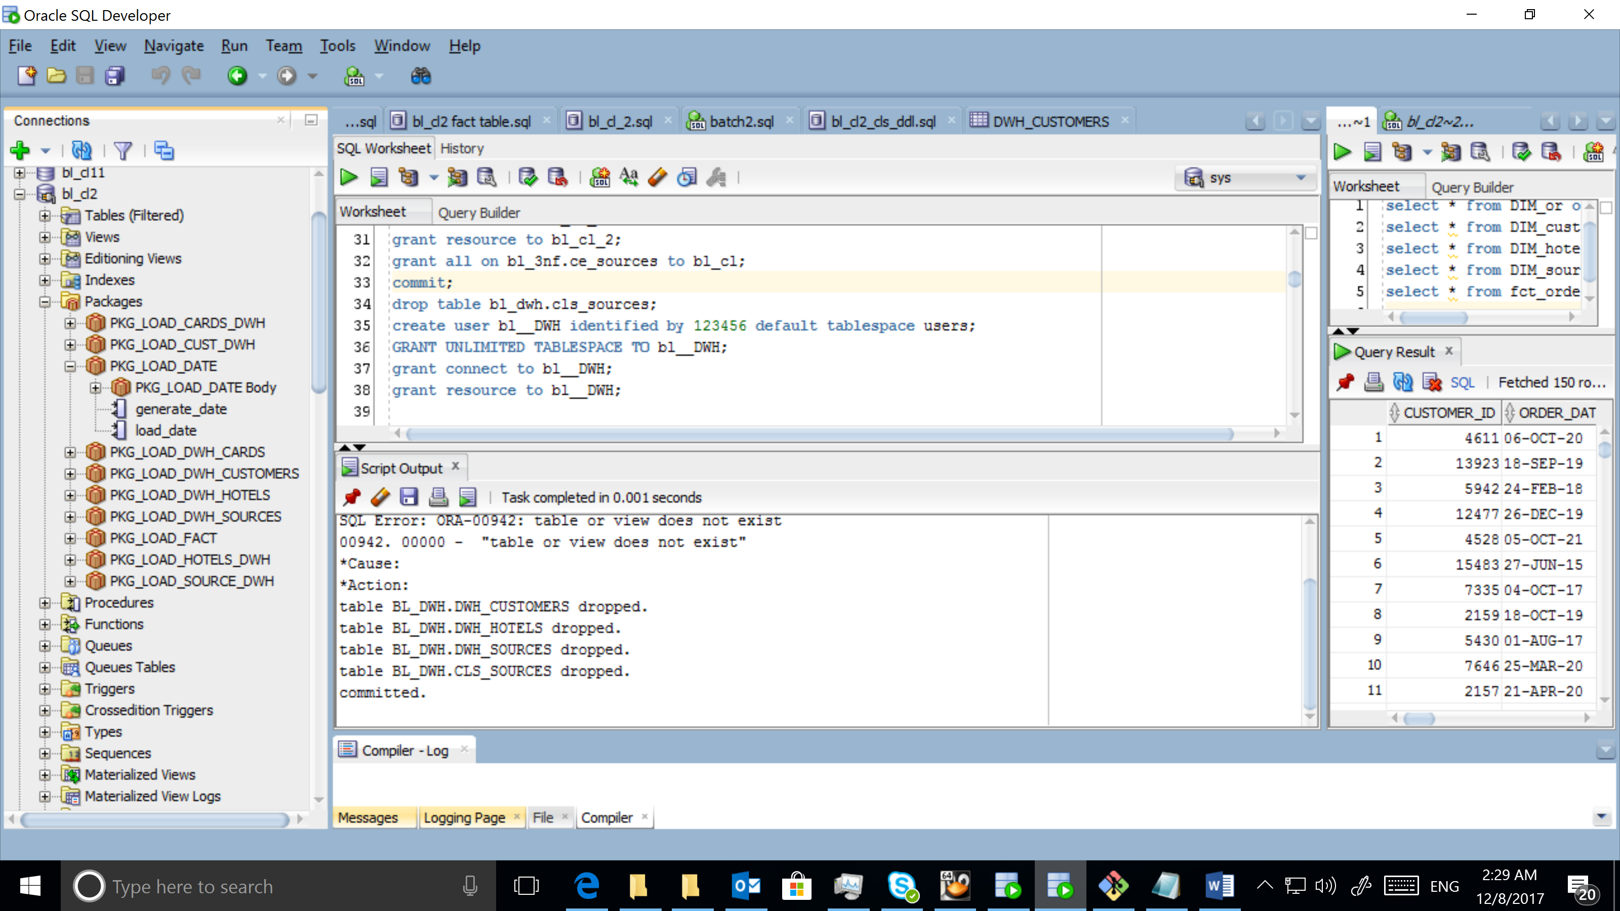

* Use Bulk Collect (One or more procedures)
* Use Forall (One or more procedures)

CREATE TABLE foreall_table AS

SELECT * FROM cls_customers;

/

DECLARE

CURSOR cur

IS

SELECT address_id FROM bl_3nf.ce_addresses;

type t__data

IS

TABLE OF NUMBER; --NESTED TABLE

t_data t__data;

BEGIN

OPEN cur;

LOOP

FETCH cur bulk collect INTO t_data limit 10000;

EXIT

WHEN t_data.count = 0;

FORALL i IN t_data.FIRST..t_data.LAST

DELETE FROM foreall_table WHERE address_id = t_data(i);

COMMIT;

END LOOP;

CLOSE cur;

END;

/

SELECT COUNT(*) FROM foreall_table;

SELECT * FROM foreall_table;

* Use a cursor FOR loop

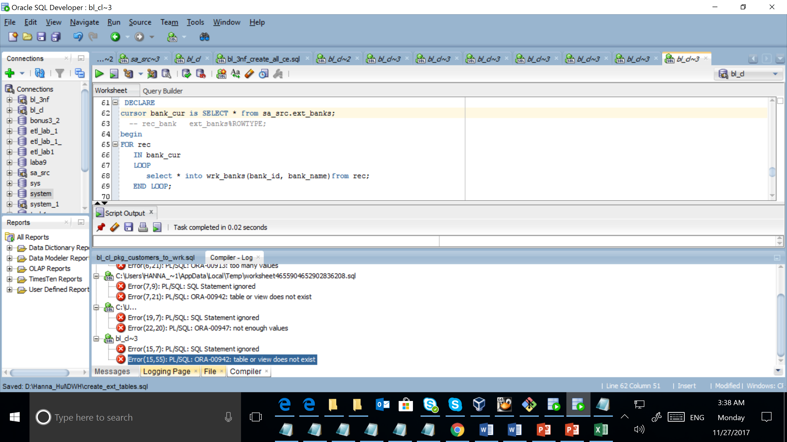

* Use EXECUTE IMMEDIATE INTO for dynamic queries

EXECUTE IMMEDIATE 'truncate table cls_orders';

* Use cursor variables

Cursor is used in the 4 task.

# Test Your Data

Prepare document with screenshots of the data on different layers. Test data for the consistency:

* Reload packages on the same data (nothing should be changed).

OK

* Reload packages with some changes to test if your SCD logic works as expected.

ОК

Start date is generated on cleansing layer.

